# Pre Interview Activity- Data

This task is to process satellite images on a grid and extract meaningful information. Aim is to know how well you understand your data.

There is 1 satellite image of night sky of Bangalore in 2019. ‘sky_2019.tif’ <in EPSG 4326>. Also there is a geosjon grid <in EPSG 4326> of Bangalore city.

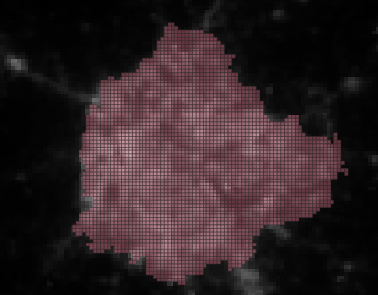

View of Bangalore City in the Night

**Task:**

Please extract the land illumination<night light> from sky_2019 coming out from each grid of bangalore. Add this as a column to the grid dataframe for analysis.

Question1: What all can you tell about night illumination coming from the grid Cells. Are there any interesting patterns you can find < any specific clusters/ grouping>.

Question 2: Please display them as a simple choropleth on a folium map.

Question 3: What do you think these findings tell you about Bangalore City.

For this analysis plz assume that there is no NULL data.

Key Python Libraries to use are :

1. Raster Analysis libraries : Rasterio & rasterstats <https://pythonhosted.org/rasterstats/manual.html#zonal-statistics>

**Introduction:** Rasters (‘.tif files’) are basically satellite photos where each pixel represents a point on earth and captures a particular variable. <EPSG 4326 is a earth’s coordinate system and should not affect your analysis. May be required for rasterio settings>. Zonal Statistcs is the pivot table equivalent in geospatial field. It aggregates the data of all pixels which are inside a grid.

2. Geopandas (similar to pandas): <https://geopandas.org/docs/user_guide.html>

3. Folium is a simple python visualization library to see geospatial data on a map. You use to see the analysis you have done on data. <https://python-visualization.github.io/folium/>

4. Plz use Jupyter Notebook. You can also use QGIS to see the data if you want else you can see in python notebook aswell. <https://www.qgis.org/en/site/>

**Guidance:**

1 If you are able to complete it, great!! If you get stuck plz tell whereever you got stuck and that’s fine as well.

2 Please do not put too much time in using different ML Algos <it is not the focus area here.>

3 Spatial files are in ‘.shp’ OR ’.geojson’ format. Both are attached. You can use either, they are same

Plz share your Jupyter Notebook in a git.

If you are having a challenge in running raster analysis <in Question1> do ping me and I will share the raster extracted data so that you move ahead with analysis.

*You will be amazed at what you will find out about Bangalore City. Hope you enjoy*